

**AIMC PROJECT Report**



By Group 7

**The report submitted in partial fulfilment of**

**PGDM Programme 2019- 2021**

**Submitted to:**

**Prof. Sharad Gupta**





*Submitted By:*

***Group B7:***

*Akshita Sharma*

*Arushi Wadhawan*

*Jatin Gupta*

*Mehul Sati*

*Shikha Sharma*

*Siddharth Gupta*

**Short Note on PBL process**

We solved various problems given to us through the Problem based learning (PBL) Process where we first discuss the problem at hand and then, brainstorm among the group to find what we know ans what we don’t know. After that information is gathered and organsied we then cluster the information which we want to find into a structure and then into tasks. These tasks are then assigned to the group members.

PBL Process includes -

PROBLEM STATEMENT

Identify the promotion related problem that the brand currently faces.

BRAINSTORMING

What we know

* Location
* Products/ services
* Target audience

What we don’t know

* Digital presence
* Competitors
* Location of different branches
* No. of branches
* Problems
* Customer relationship

CLUSTERING

* Talk with customers of Brands about their recent experience and offers
* Analyze the brand’s advertisement and track campaigns and their success
* Analyze brand’s social media presence and their competitors websites

ASSIGNING TASKS

Jatin & Shikha: Take review from customers.

Mehul & Akshita: Analyze advertisements

Siddharth & Arushi: Analyse website and Digital presence

**Introduction**

Farmery Farm Fresh Cow's Milk is an honest attempt to serve nutritious, chemical-free and preservative-free milk.  
It's an equivalent of serving fresh whole milk from your own farm while being present in an urban living

They promise to serve "Raw Unprocessed Chilled Milk" milked within 12-24 hours before delivery. This is quite unique unlike other brands where milk is 4-5 days old and heavily processed for consistency. We have no middleman, and source directly from co-managed farms. This helps control the bacterial count 4-5 times better than traditional collection center milk. Having Environmental friendly glass bottles

Glass is one of the safest materials, non-toxic and non-reactive, as compared to other packaging materials such as plastic, which can leach into food products. Our brand values don’t go with plastic or anti-environment materials, thus we use glass bottles for packaging.

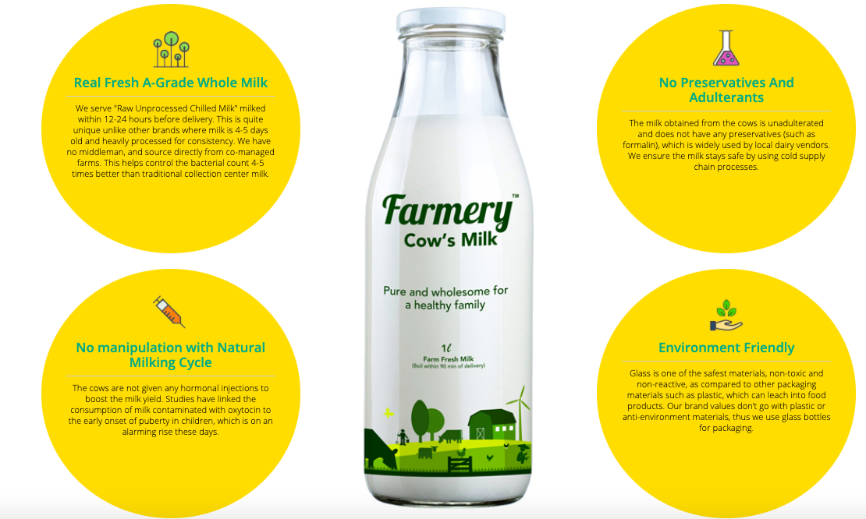

Farmery Farm Fresh Cow's Milk is an honest attempt to serve nutritious, chemical-free and preservative-free milk.  
It's an equivalent of serving fresh whole milk from your own farm while being present in an urban living

### **Real Fresh A-Grade Whole Milk**

They serve "Raw Unprocessed Chilled Milk" milked within 12-24 hours before delivery. This is quite unique unlike other brands where milk is 4-5 days old and heavily processed for consistency. We have no middleman, and source directly from co-managed farms. This helps control the bacterial count 4-5 times better than traditional collection center milk.

### No Preservatives And Adulterants

The milk obtained from the cows is unadulterated and does not have any preservatives (such as formalin), which is widely used by local dairy vendors. We ensure the milk stays safe by using cold supply chain processes.

### No manipulation with Natural Milking Cycle

The cows are not given any hormonal injections to boost the milk yield. Studies have linked the consumption of milk contaminated with oxytocin to the early onset of puberty in children, which is on an alarming rise these days.

### Environment Friendly

Glass is one of the safest materials, non-toxic and non-reactive, as compared to other packaging materials such as plastic, which can leach into food products. Our brand values don’t go with plastic or anti-environment materials, thus we use glass bottles for packaging.

(Source: www.Farmery.in)

**Reason why advertising strategy is weak**

* No use of word Reusable bottles which is one of their unique selling point.
* No instructions for “How to Place an order” on website and ads.
* Delivery time management issues.
* “Call to Action” Not persuasive. Enough on advertisements.
* Free sampling, door to door selling thus, the marketing costs are very high.
* Delivering to RWA and marketing in RWA for Door to Door approach require a good amount of wefare deposit sum required to be submitted thereby increasing further costs.
* Only 10-15% conversion rate and 60% retention rate per month for new acquisitions.

**How can we improve the brand strategy**

* Allocating the delivery boys as per the respective areas and giving them the training about the areas with flighting scheduling of ads
* Use of both Digital marketing and traditional marketing For creating and increasing awareness for the brand.
* Publishing YouTube Vlogs – infuencers using Farmery’s products in their meal recipies.
* Start Loyalty Card Program (Premium Customer Program) for retention.



**Problems currently faced by the brand -**

* Door to Door marketing –Low conversion rate, High churn rate, very high cost
* Salience: Low brand Identification, Low awareness
* Print Ads – High cost but low conversion rate (40%)
* Reason for high churn rate - due to product type
* Marketing activities not in sync with operations.

PROBLEM STATEMENT

* Classify the communication objectives. Perform thorough research for designing the campaign.
* Create the marketing communication strategy using the marketing communication work plan format based on existing market and competitive situation for the product category.

BRAINSTORMING

What we know

* Plant in Gurugram
* Door-to-door presence
* Limited customer target area
* Product/service

What we don’t know

* Commercials, hoardings/flyers
* User website experience
* Competitors
* Level of engagement
* Type of audience

CLUSTERING

* Problems currently facing
* Customer experience
* Availability on digital platform
* Telephonic interview

ASSIGNING TASKS

**Jatin & Shikha: Analyze digital presence of company.**

**Mehul & Akshita: classify communication objectives.**

**Siddharth & Arushi: Research, Telephonic Interview**

**Communication Objective**

**Brand image**

* Focusing on providing chemical residue free organic products

**Competitive positioning**

* Through door-to-door services and providing different offers they wanted to create brand awareness.
* Moving to digital platforms, trying to increase the market penetration.
* Using different strategies to increase the customer base.

**Research:**

Primary research through telephone with Mr. Mohit Bajpai (Business development) where information like:

* Marketing strategies and channels adopted till now
* Effectiveness of marketing activities, churn rate, retention rate

Were taken from him.

Secondary research done through Instagram and Facebook posts.

[*References: https://www.facebook.com/FarmeryFarmFresh*](https://www.facebook.com/FarmeryFarmFresh)[*https://www.instagram.com/farmeryfarmfresh/*](https://www.instagram.com/farmeryfarmfresh/)

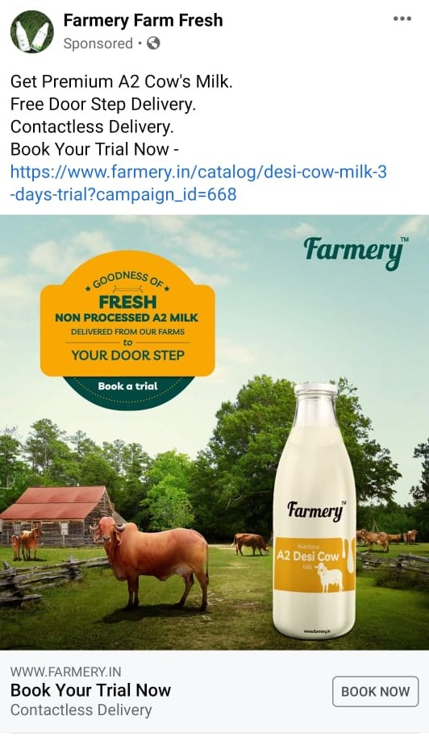

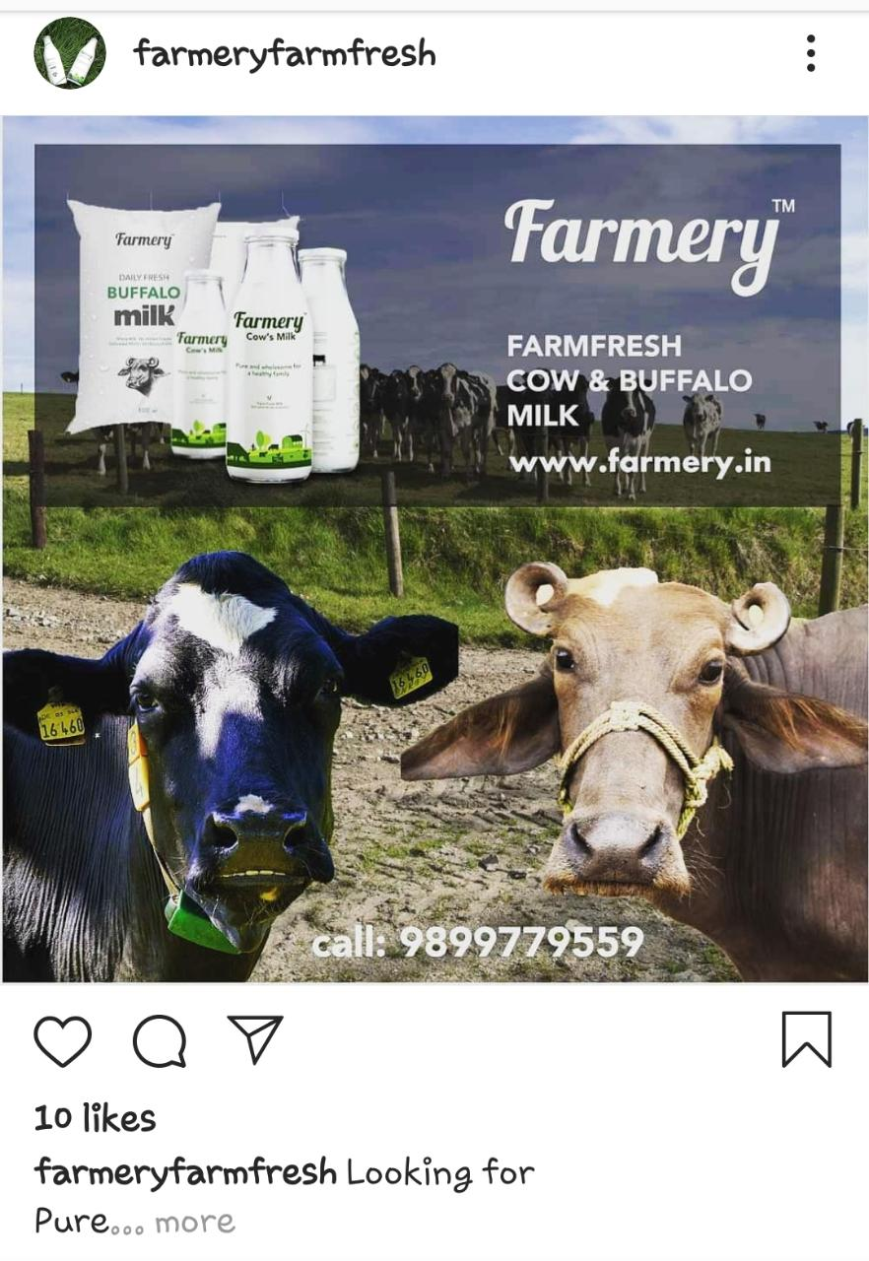

**Marketing communication strategy using the marketing communication work plan**

* **Product description**: Farmery Farm Fresh Cow's Milk is an honest attempt to serve nutritious, chemical-free, and preservative-free milk.  
  It's an equivalent of serving fresh whole milk from your own farm while being present in an urban living

Farmery’s A2 Desi cow milk is Pure and organic. The milk comes from highest grade desi Indian cows and is directly sourced from company managed farms. It is organic because the fodder that is fed to the cows is free of pesticides and any chemical additives.

The milk is not processed and is not standardized (pasteurized) so the customers get purest form of milk delivered to their doorstep in the morning.

The milk comes in 1 litre glass bottles which are returned to the company and the customers get fresh and hygienic bottles everyday. This is a measure taken by the company, so that the materials it uses for its products are environmentally sustainable.

The price of the product is 100 Rs per litre.

* **Prospects**: Families living in Urban residential areas.

Target: Moms who wants to give their child the best possible nutrition.

Age: 26 and above

Sex: Females and males (80:20)

Education: Graduation/Post graduated.

Occupation: working professionals and home makers

Lifestyle: Upper middle class, Who are into organic products and environment conscious. They focus on their simple living high thinking mantra and are conscious of the products that they buy.

* **Product Personality**: Healthy, honest and Environment conscious
* **Rewards:** PLEASE FILL
* **Competition**: Four us, Binsar farms, YT farms, Country delight. Country delight is not a competitor as the products are different but its sells on the same proposition as farmery.

All other competition is small but is gaining larger market share every month. Farmery as better market penetration as they have done additional surveys during the time, they are doing door to door selling and they believe that they know their customer better.

Company is working on its **blue ocean strategy** where the cost price of the product is lower than the competitors and the product is differentiated. (non-standardised milk, A2 grade). It aims to create new market and then expand it.

Farmery has employed a dedicated employee for reducing the churn rate.

* **Obstacle**: If the milk is not delivered on time that is between (5am – 8am), Why do they trust a new company making a similar claim as country delight or other start ups.
* **Message Objective**: Increase brand awareness, Portray the USPs, Giving them trust on timely delivery.

Source: Telephonic Conversation with Mr. Mohit Bajpai (7983913184), Farmery

PROBLEM STATEMENT

Finalize the big idea for your chosen brand.

Evaluate alternate ideas.

BRAINSTORMING

What we know

* 1. Product/services
* 2. Problems currently facing
* 3. Message

What we don’t know

* Different ideas
* 2. Strategy used
* 3. Platform
* 4. Situation
* 5. Shortcomings
* 6. Execution elements

CLUSTERING

* Advertising Strategy
* 2. Big idea
* 3. Creative execution

ASSIGNING TASKS

**Brainstorming of Big Idea and contribution for Strategy, Big idea, Execution by every member.**

**Different ideas for Farmery –**

**#1**

**Strategy –**

Communicate the use of fresh farmery products

**Big Idea –**

Using “fresh food” to make tasty and healthy items

**Execution Elements**

Use of hashtags; selection of right characters

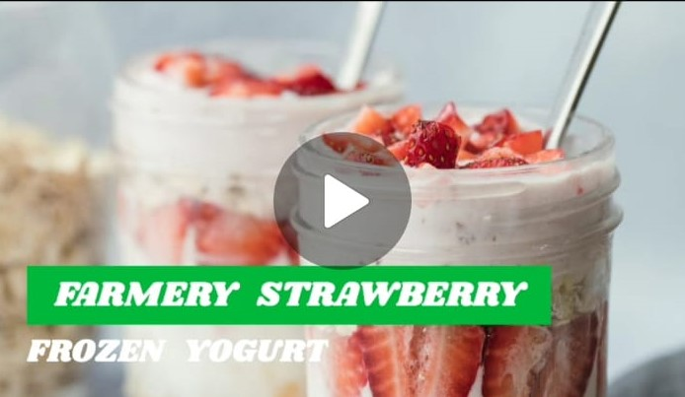

Evaluation : Would not be so effective for just creating brand awareness. Can be used later by the brand as reinforcement strategy.

#2

**Strategy –**

Establish trust through customer testimonials

**Big Idea –**

Informed moms, intelligent choice

**Execution Elements**

Selection of right platform; involvement of real time customers

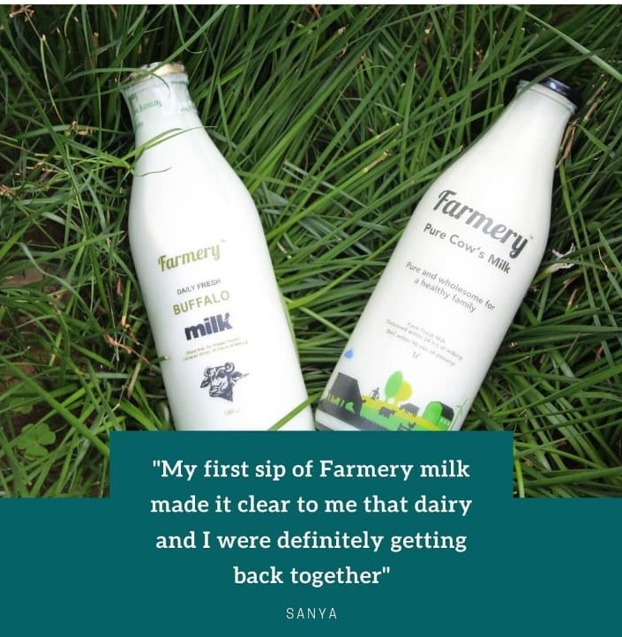

#3

**Strategy –**

Demonstrate that getting old way of sourcing raw milk was better

**Big Idea –**

Bringing back healthy days with farmery ways

**Execution Elements**

Creative tagline; apt sound effects; inspired by real word situation

Evaluation : views may find it difficult to relate since it would be a first ever TV advertisement for Farmery.

Also, it focuses on only one target segment and not all.

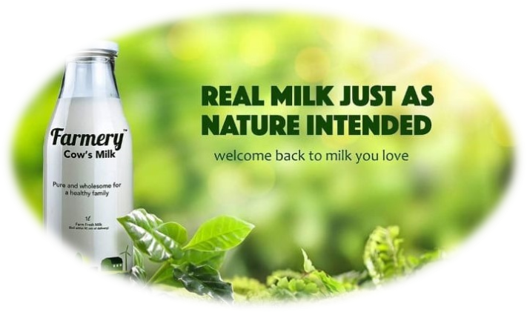

#4

**Strategy –**

Integrate Farmery’s product into customers’ daily life

**Big Idea –**

Make organic fruits and milk as daily breakfast ritual

**Execution Elements**

Selection of right characters; a soft music in the background; storyline

Evaluation : Good Idea, can be considered but may be difficult to execute.

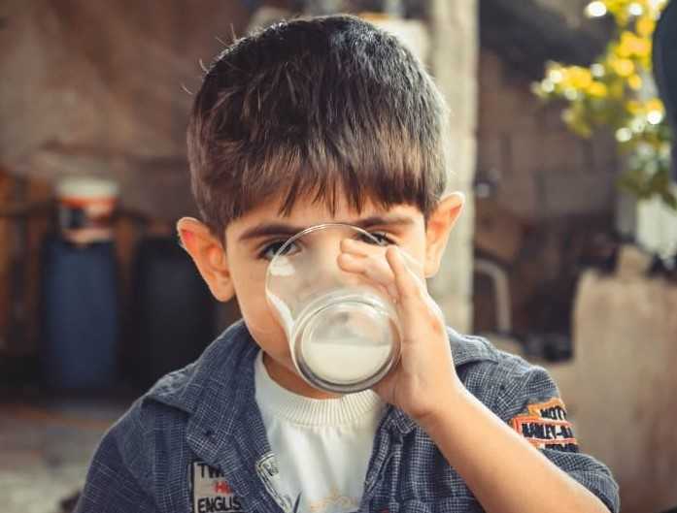

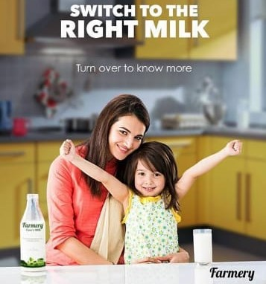

#5

**Strategy –**

A health and fitness influencer use farmer’s products

**Big Idea –**

Organic products are used by fitness freaks

**Execution Elements**

Selection of right characters; apt sound effects; elements of humour

Evaluation : Would not be so effective for just creating brand awareness. More suitable for viewing on Digital Platform.

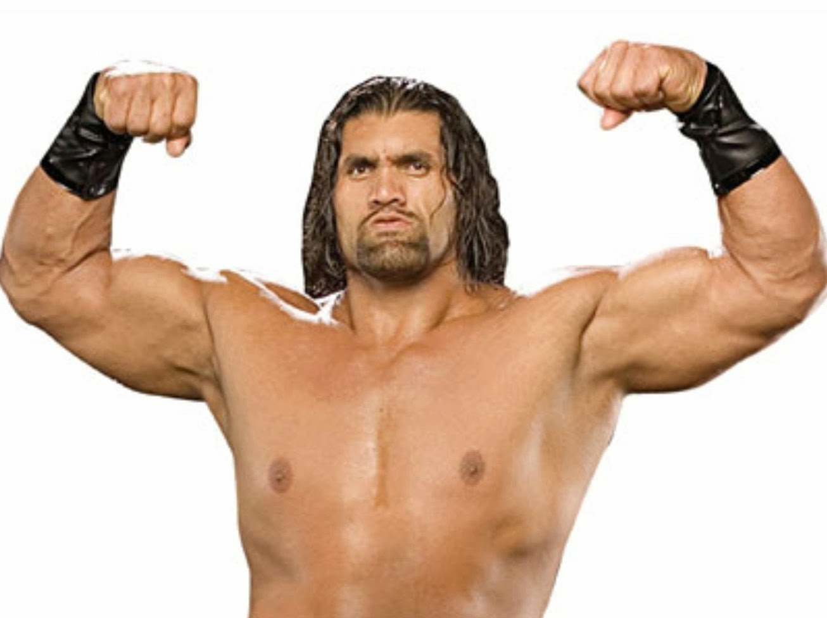

BIG IDEA –

#2

**Strategy –**

Establish trust through customer testimonials

**Big Idea –**

Informed moms, intelligent choice

**Execution Elements**

Selection of right platform; involvement of real time customers



Reason for the selection of the Big Idea

* **Television commercial will have a wider reach and the Advt is apt for national Audience.**
* **Generate more trust factor amongst the customers**
* **Idea in line with solving one of the prpblems that brand faces ie. Low awareness along with creating a sense of trust among the customers.**
* **Apt for whole of the target segment**

PROBLEM STATEMENT

Prepare a creative brief using the format of your choice for your campaign.

BRAINSTORMING

What we know

1. target audience

2. About the brand

3. Competitors

4. Advertising strategy

5. Big idea

What we don’t know

1. McCann-Ericson’s Role-Playing Approach

2. Creative brief checklist

3. Types of other creative execution elements

4. Personality and tone of advertisement

5. Positioning

6. Consumer’s perspective

7. About the campaign

CLUSTERING

1. About the brand

2. About consumer perspective

3. About competitors

4. About the big idea

ASSIGNING TASKS

Questions were selected in all the topics under clustering and each member was given a certain set of questions to give their analysis on it.

**Creative Brief**

The brand chosen is **Farmery.**

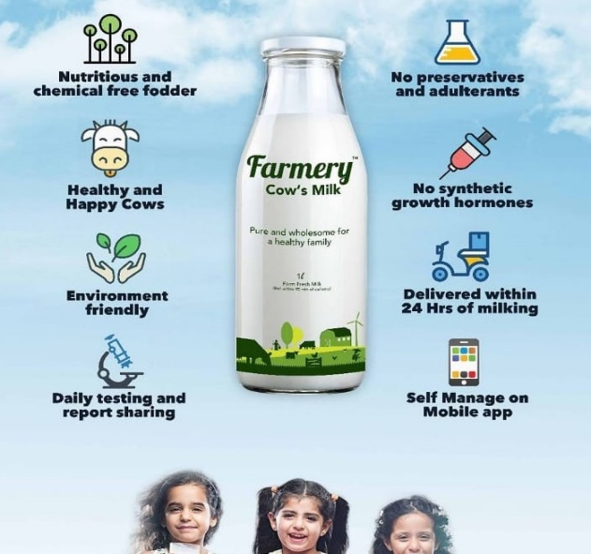

1. Who is our target?

* Working professionals, fitness freaks who believes is purity and Raw processed milk.

2. Where are we positioned in the mind of the target?

* “I have never heard of farmery milk.”

3. How does our competition fare in the mind of the target?

* “There are number of other doorstep milk delivery dairies around but as I am a working professional and I don’t have time to go out early in the morning to buy milk, so I thought of choosing a product which is giving home delivery plus healthy and processed milk at my door step.”

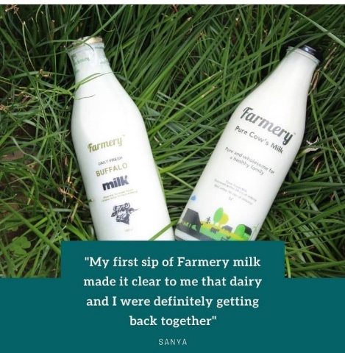 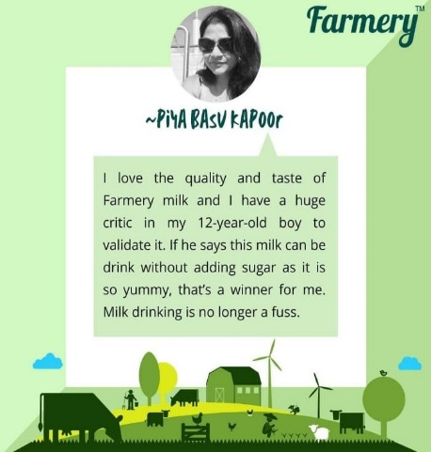

4. What is the ideal positioning we seek with the target?

* “I use farmery’s chemical free fresh milk as a daily ritual in morning and evening both. I trust this brand as it is natural and pure and makes my family healthy without consuming products that have chemical additives.”

5. What is our consumer promise, the ‘big idea’?

* “Farmery is a conscious choice accepted by everyone as it is pure, organic and healthy.”

6. What is our supporting evidence for the ‘big data’?

* “I know that some women use organic milk to make their children stronger and healthy. May be the same product will work on my family too.”
* “Farmery uses glass bottles which is one of the safest materials, non-toxic and non-reactive as compared to other packaging materials such as plastic, thus providing eco-friendly and safe products.”
* “Farmery organic milk contains all 20 necessary amino acids which strengthens the immune system.”

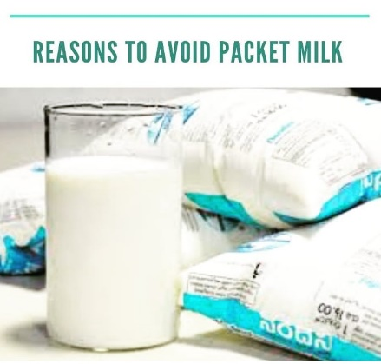

7. What is the tone of the advertisement?

* The tone of the advertisement is religious, friendly and advisory. The advertisement is trying to grab the attention of the audience by relating to god and thus advising them to prefer the purest form of milk. It is creating a sense of friendliness by showing the original farms from where the cows are kept and vegetables and fruits are grown.

8. What mandatory elements should be included in the advertisement?

* Company logo, music, product details

**The Creative Brief Checklist**

1. What is being advertised?

* A man while on his way to a temple wants to offer milk to the Gods, he sees other people using plastic bags and standardised milk, mixing it water and then makes a conscious decision to take a farmery glass bottle of farm fresh raw milk instead for the gods, he uses the bottle and puts it back in his bag. He feels satisfied and happy by making the right choice. After the short, farms and cows are shown in the advertisement and USPs of farmery's Desi cow milk is shown in the video.

source:

2. What is the key task this campaign is designed to accomplish?

* Appeal to the consumers to make the right choice by selecting farmery's organic products and stablish trust for the brand.

3. Whom do you need to influence?

* We need to influence the Moms, professionals and people who are conscious of using environment friendly products and who are conscious of making the right choice. We also need to influence people who are into fitness programs, and older people.

4. What do you know about your audience?

* Audience comprises of parents who want to give the best to their child and they buy what's best for them and the environment. The fitness buffs may themselves be influencers for other people. The older people want the good old ways back of getting fresh farm milk which is raw and organic to their doorstep in the morning everyday.

5. What do you want them to do?

* Trust the brand – make organic fruits and milk as daily breakfast ritual. As it brings farm fresh hygienic milk sourced form exclusive farms, a gift of pure chemical free products and unadulterated buffalo milk.

6. What can you say or what reward can you associate with the action that will get them to do that?

* Accepted by heavens, trusted by everyone.
* Rewards:

One-month subscription + 2 litters milk free

Achieving 100 points will get you Farmery hamper

7. Who are your major competitors?

* Competitors- Four us, Binsar Farms, YT Farms

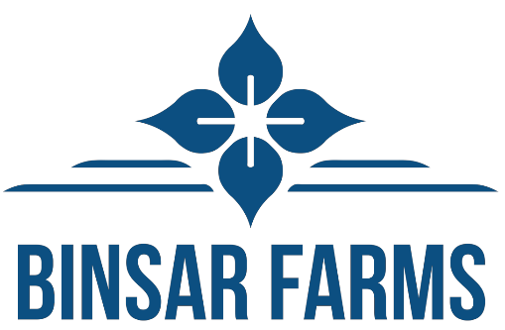

8. How do they advertise?

* Advertise through television commercials as it will have wider range and Generate trust factors amongst the customers.
* Use websites, android/ IOS application, where customers will have more knowledge about the new offers’ products rendered.

9. What is the main reason consumers should choose you over your competitors?

* Organic and GMO (Genetically Modified organisms) free products such as milk, fruits and vegetables. Brand is focused on healthier future generation.

10. What is your ‘big idea’ or key message?

* Big idea is to cater the nation with a natural and fresh product.

11. How will you know it worked?

* Comparing farmery's customer retention rate with that of competitors.
* Through customer feedback forms.
* Frequency of orders.

12. What is your tone and style of voice?

* Tone- persuasive and sympathetic
* Voice- humorous

13. What personality do you want to convey?

* Strong, friendly, creative, persuasive

14. Where and when would the audience be most receptive to the communication?

* At the time when in the advertisement the god was shown accepting the farmery milk and rejecting the other brand, the audience would be attracted by this and trust the brand more. The religious factor will add more to this.
* The audience would be the most receptive to the communication during the evening as the target audience- the mothers are generally engaged with the television at that time.
* Also, communication through the radio during the morning time would be impactful too.

15. What is the key insight in this strategy?

* Accepted by everyone as it is organic and healthy. Farmery brings pure cow milk directly from the farms to your table each morning.
* No pesticides, chemicals or additives
* No added fat
* Milked from healthy cows with utmost hygiene.

16. What are the mandatory creative elements that need to be included in the ad?

* Mandatory creative elements - Company logo, Product shot ( Farmery's Desi cow milk in a reusable glass bottle), Temple Bells, Farms with Clean cows and fodder in open space, humorous tone of the characters, Company's Green and white colour scheme.

PROBLEM STATEMENT

Create a print ad for your campaign. Write your copy on a separate sheet of paper and show copy placement in the ad with lines

BRAINSTORMING

What we know

1. about the brand

2. target audience

3. intended communication message

4. print medium

What we don’t know

1. visuals to be used

2. design copy

3. design elements

CLUSTERING

1. elements of print advertising

2. visuals

3. body copy

4. other display copy

ASSIGNING TASKS

Arushi, Jatin, Shikha, Siddharth, Akshita: contributed in designing the print advertisement using different advertising elements.

Mehul: prepared the print advertisement for the newspaper

**Print ad for the campaign**

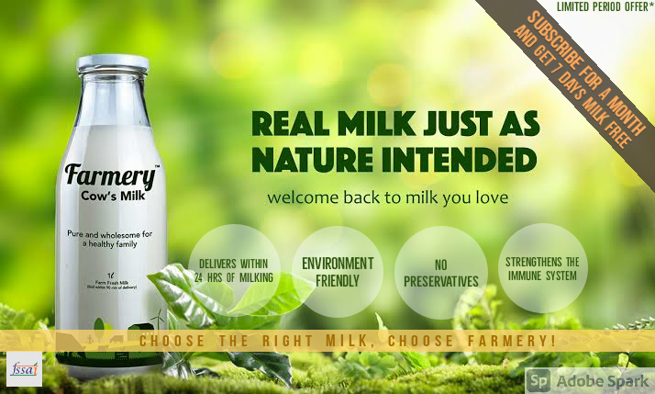

**The Print Medium**

* As our target audience are mainly the moms that are concerned for the health of their children. So the print medium chosen is **the newspaper**. As it is cheap and convey a lot of information to our audience and thus will help to increase the reach.

**Elements of Print Advertising**

**Layout:**

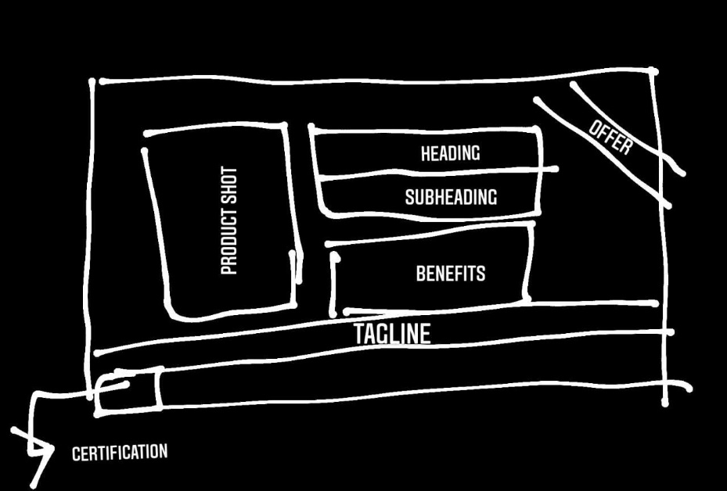

**Headline:**

**REAL MILK JUST AS NATURE INTENDED**

* The headline focuses on the fact that Farmery provides real milk that is raw, fresh and organic with no additives that comes directly from the farms.
* It is a benefit type of heading as it is straightforwardly telling the audience that the milk that they provide is the best for their family.

**Subhead:**

**Welcome back to the milk that you love**

* Subhead will intend to communicate a part of business strategy.
* With this subheading we're trying to establish a feeling of nostalgia among our target audience. Just like in the old days people used to consume raw milk which was not processed and came directly from the animal.

**Tagline:**

**Choose the right milk, choose Farmery**

* Use the same tagline for reinforcing the value proposition: Choose the right milk, choose farmery!

**Body Copy:**

* Follow the bulleted approach
* Display the advantages of switching to farmery's products

1. delivers within 24 hours of milking
2. environment friendly (packaging)
3. no preservatives
4. strengthens the immune system

**Visuals and type of visuals:**

The visuals that are used are the images that include the bottle of the milk and the nature that indicates the green and fresh farms.

* highlighting the main services and quality offered.
* To grab the attention, offers and discounts are shown with different colours so that it can be highlighted to the customers.
* Green colour represent that Farmery provide pure and organic products.

**Page Personality:**

* headlines and visuals relate to each other as both represents purity and freshness.
* All the words, visual ideas and design elements used are very specific and providing information that represents the brand and its products.
* Customers can easily understand and remember the information presented

**Other design elements:**

* Fonts are different enough to be easily distinguish from one another
* Headline used can easily capture a moving audience with a message

PROBLEM STATEMENT

Prepare a radio script and radio commercial

BRAINSTORMING

What we know

* Advertising strategy
* Communicating message
* About the brand
* Basics of digital audio workstation

What we don’t know

* Radio script
* Radio advertising elements
* Sound/FX
* Creative execution
* Expression

CLUSTERING

* Structure
* Radio elements
* Radio commercial

ASSIGNING TASKS

Everybody contributed in making radio script

Shikha and Jatin – voice for Ad

Mehul – Edit and master Audio track

RADIO SCRIPT

**Beta:** Chlo maa, mere nikalne ka time aa gya hai. Aur 10 minutes mein taxi bhi aa rae hai.

**Maa:** Arrey beta vo toh theek hai liken wahan teri sehat(health) ka dhyan kaun rakhega? Pichli baar bhi aya tha itna patla dubla hoke. Vahan bhi to thelliyon (packets) ka doodh milta hai.

**Beta:** Maa aap bohot tension lete ho chinta ki koi baat nhi hai. Maa wahan Farmery aa gya hai.

**Maa:** Farmery? Ye Farmery kya hai?

**Narrator 1:** Ji haan agya farmery cow milk, your new fitness partner with no added fats, no preservatives and with high nutrition. Jald se jald farmery app ko download kijiye ya log in kijiye www.farmery.in pr

**Narrator 2:** Farmery dood ismei hai maa k pyaar k sath protein bharpoor, dimaag chalein ek dum khoob , Challo aao ab sab peeye gaaye ka shudh doodh



**Radio commercial elements**

* Communication message: The brand is conveying the message that their milk is organic and free from preservatives and is pure which makes it healthy.
* Background sound effects that includes music, cow’s voice, bird chirpings, usage of emotional music and joyful music
* Dialogue format to dramatize the situation
* Multivoice

PROBLEM STATEMENT

Prepare a television script and storyboard. Pay attention to the ABC’s of scriptwriting and production. Ensure consistency of your theme and message across all media.

BRAINSTORMING

What we know

* About the company
* Problem faced by brand
* Big idea

What we don’t know

* Different elements to be used in TV commercial
* How to write a script
* Prepare a storyboard
* Content to be added

CLUSTERING

* Advertisement elements
* Making TV commercial
* Process to create the commercial

ASSIGNING TASKS

* Jatin Gupta, Siddharth Gupta, Arushi Wadhawan: Process to create the commercial
* Shikha Sharma, Akshita Sharma, Mehul Sati: Making TV commercial

OBJECTIVE: To solve a Problem faced by the brand

**Brand’s Value proposition needs to be highlighted along with introduction of the brand’s name: Farmery**

**Farmery has low brand awareness**

**Since, the positioning the brand seeks is different from its competitors**

**TV Ad Script**

Farmery : 43 “farmery real milk”

Background music guitar with “ting” SFX sound intermittently – throughout the ad

Scene 1: [A working class female, in formals drawing attention to the scene. (Intro in Audio, attention catching short background music)]

***NR1(FVO 22): Welcome to Farmery,***

Scene 2: [intro contd. Depiction of farm fresh air felt on hands, background music guitar with “ting” SFX sound intermittently]

***NR1(FVO 22): Where you will get all the products naturally from the farms.***

Scene 3: [Focus on cow (talk about problem of getting fresh milk every day]

***NR1(FVO 22): Finding Pure and Fresh milk is the biggest challenge these days… but not anymore.***

Scene4: [providing solution to the problem, displaying a poster, cows feeding on grass with green background giving a sense of natural and organic feeding of cows, cows are clean, and grass is green]

***NR1(FVO 22): Farmery’s bringing fresh milk to your doorstep. The source of fresh milk is grass-fed cows which is a complete food in itself.***

Scene 5: [portraying Farmery’s USP through audio and video]

***NR2(FVO 25): Our milk is free from chemicals and preservatives.***

Scene 6: [Now Available in your city. (with accompanying animated video)]

***NR2(FVO 25): Now Available in your city.***

Scene 7: [zoom out of last animated poster. Green background with product shot (desi cow milk), call to action through voice and text.]

***NR2(FVO 25): Farmery real milk. Just as nature intended.***

***NR2(FVO 25): follow us on twitter and Instagram and for more details check our website www.farmery.in***

**Story Board**

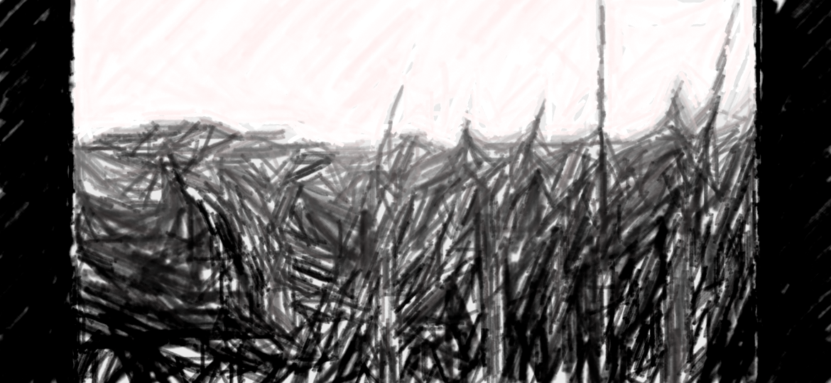

“Wholesome Milk starts with the cow’s healthy diet”

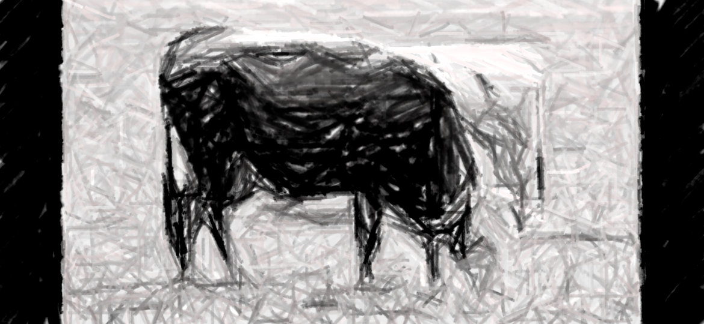

Cows roam and gaze freely outdoors.

Cows consume their natural diet of grass as grass fed products are significantly higher in nutrition and minerals.

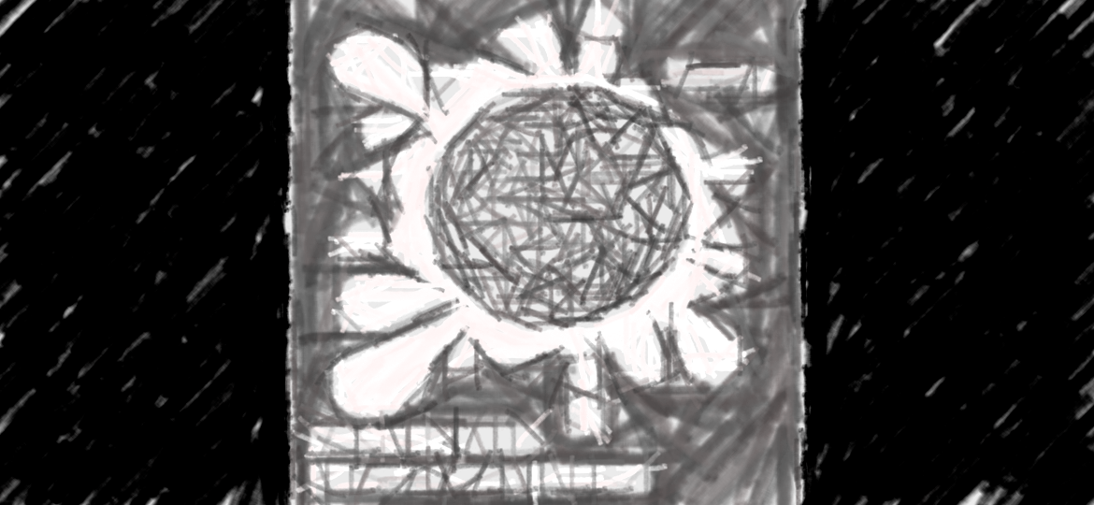

It’s an equivalent of serving fresh whole milk from your own farm while being present in an urban living. No need to rush, delivered at your doorstep.

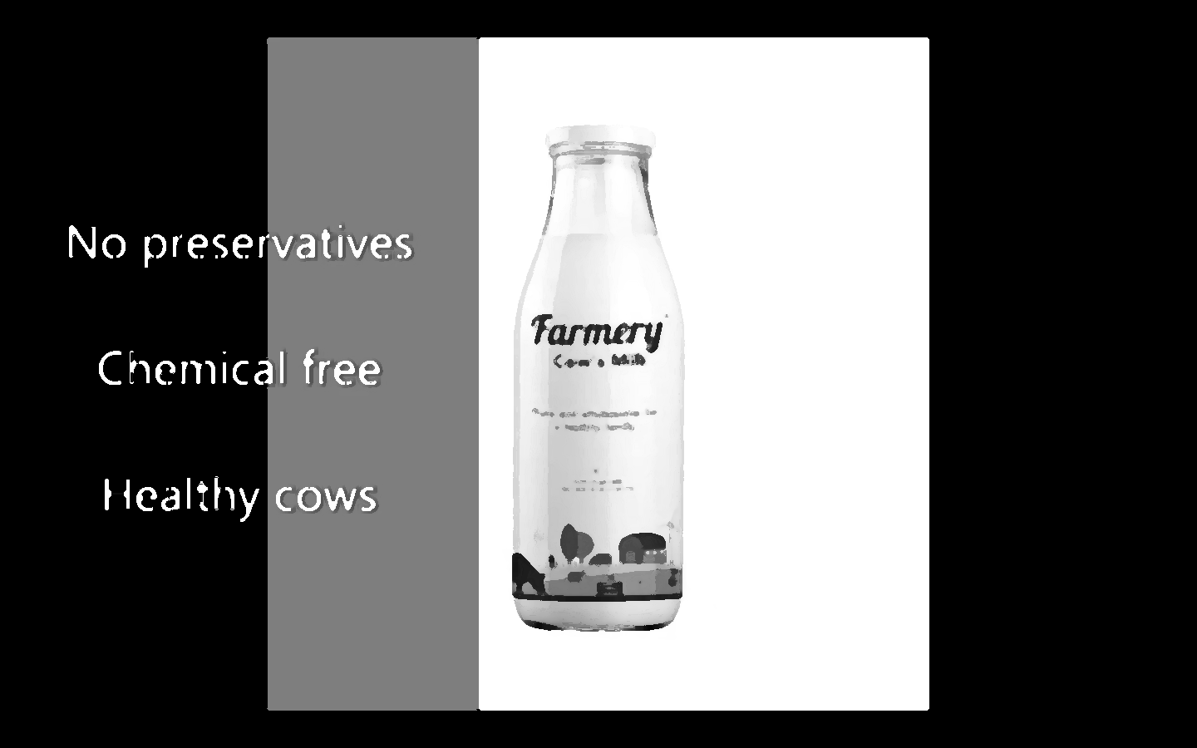

The farmer cow milk is natural, organic and pure and free from any preservatives and chemicals. Thus it is very healthy.

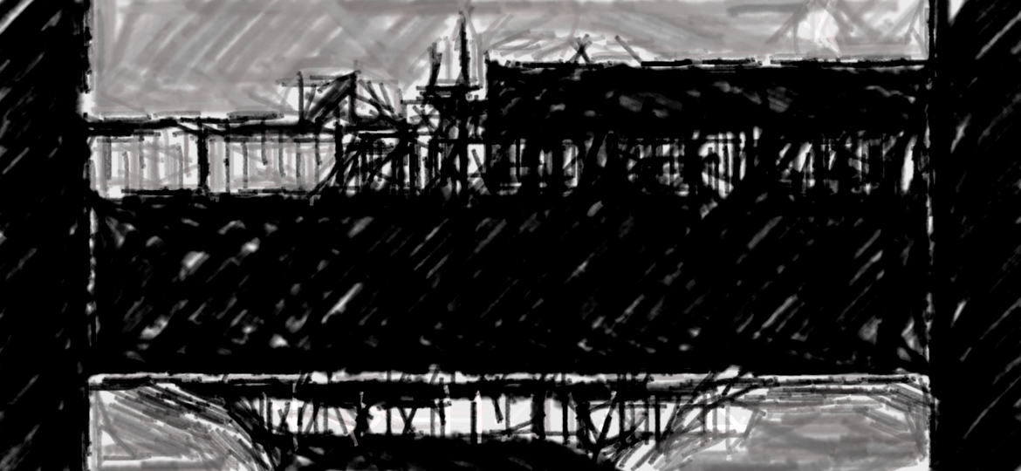

Now we are available to deliver milk to your doorstep.

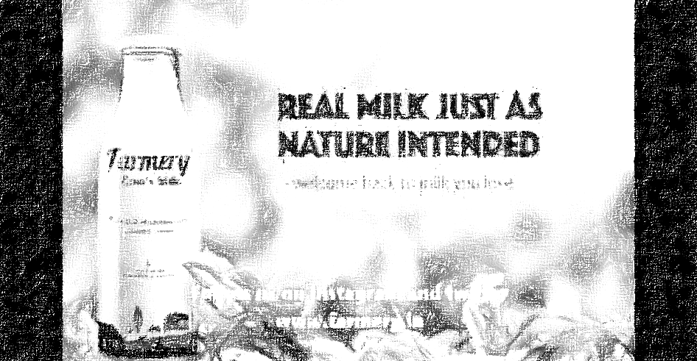

Nature’s fresh cow milk with:

no added preservatives straight from the farm.

Call to action: Use our android/ios app

Register on our website- [www.farmery.in](http://www.farmery.in/)

Join us at Facebook, Instagram, twitter

**Television Commercial**

